Chapter 1, Problem 20.

Find V₀ and the power absorbed by each element in the circuit of Fig. 1.31.

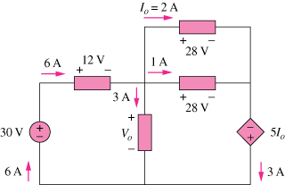

Figure 1.31
For Prob. 1.20.

